**Test Case #3 – Interior walls and Floor Second Level Space Boundary Test**

*Test Description* : A 5-zone model with overlapping zones and a double-height zone. This test is designed to ensure that the tool used to create the zones can properly follow the basic conventions for second level space boundaries.

1. Second Level Space Boundaries should be created automatically though surfaces are drawn naturally in BIM tool
   1. Exterior walls drawn overlapping zones – BIM tool must be able to break up the surfaces and zones as per the definitions of a second level space boundary, without user intervention.
   2. Interior walls drawn overlapping zones – BIM tool must be able to break up the surfaces and zones as per the definitions of a second level space boundary, without user intervention.
   3. Floors drawn overlapping zones – BIM tool must be able to break up the surfaces and zones as per the definitions of a second level space boundary, without user intervention.
   4. Ceilings drawn overlapping zones – BIM tool must be able to break up the surfaces and zones as per the definitions of a second level space boundary, without user intervention.

*Space Name(s):* This is important because the gbXML validator requires the strings in the test file match the standard file. The name check is case sensitive. Ensure that the id attribute of the Space elements in the gbXML test file match the standard file space names shown below.

|  |  |  |
| --- | --- | --- |
| Standard File Space Name | Test File Space Name | Verified |
| sp-2-Space |  |  |
| sp-3-Space |  |  |
| sp-4-Space |  |  |
| sp-5-Space |  |  |
| sp-6-Space |  |  |

*Special Considerations:*

1. This is a simple second level space boundary test.
2. Many of the surfaces have been drawn naturally, meaning the user has not intentionally drawn the model to account for 2nd level space boundaries

*Complexity of the BIM Model:*

1. Simple planar surfaces orthogonal to the project Cartesian reference frame.
2. Single wall thickness throughout the project
3. Simplified walls with no visible layers.
4. Simple details at interfaces of surfaces.

*Description of Test:*

Figures 1 and 2 diagram the basic schematic outline of the floor plans. The test file is a two story building without plenums. Spaces 2,3 (on level 1) and Spaces 5,6 (on level 2) share a common interior ceiling that is drawn in the BIM as a single floor. Figure 3 shows a section cut of Spaces 2, 3, 5, 6. A double height space, labeled Space 4, spans both Levels 1 and 2, and its west wall shares an interior wall with all the remaining spaces 2,3,5,6. This west wall is also drawn as a single, large wall.

The 2nd level space boundary agreement requires that the common interior ceiling and floor common to spaces 2,3 and spaces 5,6 be broken into separate interior partitions for the purposes of energy modeling, although the floor has been drawn as a single floor slab in the model. Additionally, the 2nd level space boundary agreement requires that the western interior wall of Space 4, that is adjacent to all the remaining spaces, be broken into separate interior walls for energy modeling purposes, though the wall has been drawn as a single wall in the BIM. Figure 4 shows a 3D axonometric cutaway with the relationships between Space 4 and the other spaces along the shared interior wall.

Other notable features of this test example are the exterior walls of Space 4. The southern and northern exterior walls are extensions of the southern and northern exterior walls of Spaces 2,3,5,6. Therefore, Space 4 has 2 exterior walls on the north, and two exterior walls on the south. The east exterior wall of Space 4 is a single, double height wall. The gbXML file should also reflect this design assumption, regardless of the construction assignment, i.e. – those exterior walls that are drawn as two separate walls shall be two separate walls where required in the gbXML file.



(double height space)

Space 4

Space 3

Space 2

Figure : Level 1 Space Plan View.

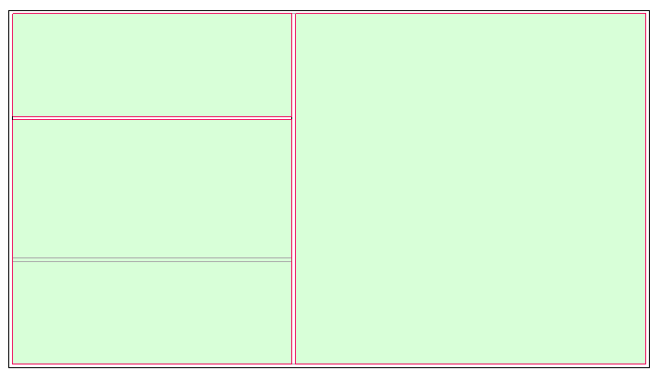

(double height space)

Space 6

Space 5

Space 4

Figure : Level 2 Space Plan View

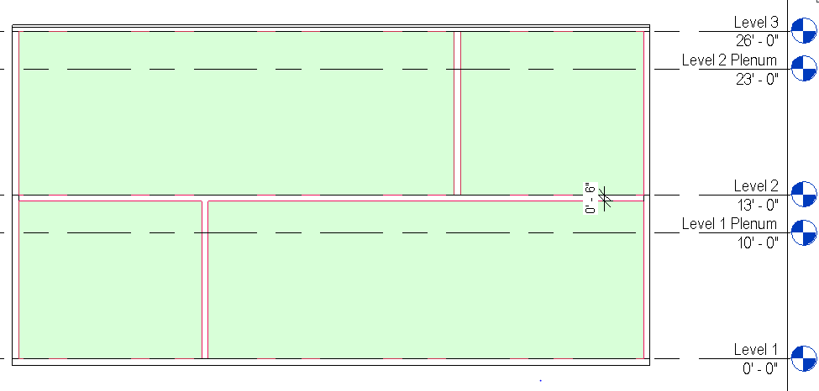

Space 3

Space 2

Space 5

Space 6

Figure : Section cut of Spaces 2,3,5, and 6. Internal floor thickness is shown (6").

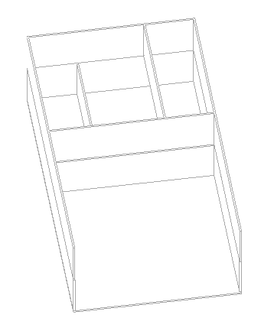

Space 4

Space 3

Space 6

Space 5

Space 2

Figure : 3D cutaway view showing the west interior wall of Space 4 and its neighboring relationships to Spaces 2, 3, 5, 6.

*Geometry Descriptions*

Below in Figures 5-9 there are listed dimensions that provide additional information about the specifics of the geometry for this test case, that can be used to reproduce the geometry. The project origin is specified in some images by the  symbol.

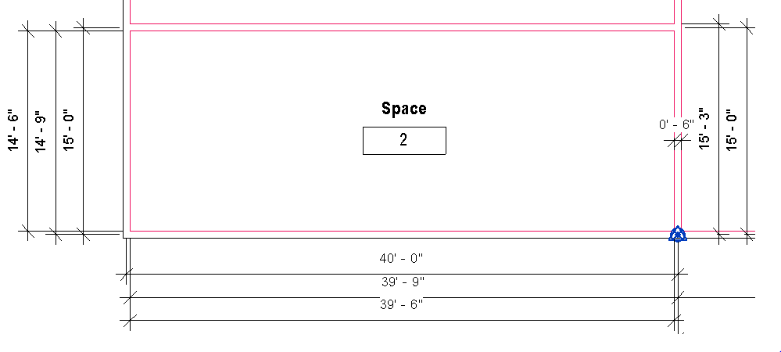

Figure : Detail of dimensions of Space 2. Project Origin and Wall Thickness are noted.

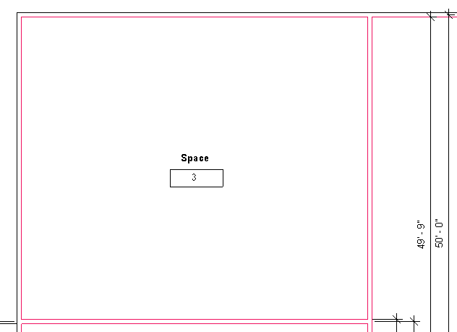

Figure : Details and Dimensions of Space 3. Space 2 dimensions can be referenced for the X-Y dimensions

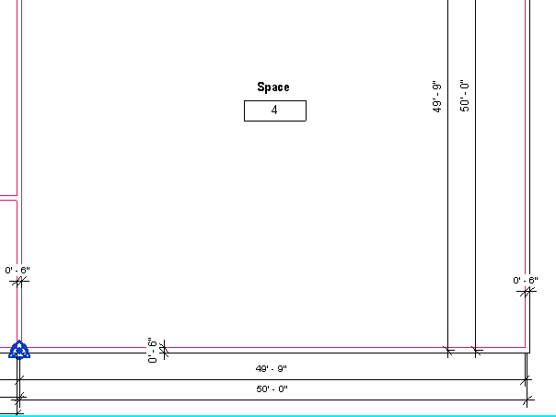

Figure : Space 4 dimensions shown. The north exterior wall could not be shown because it would obscure the text. However, the space is a square space and thus the interior surface of the northern wall is 49'9" in the Y-direction from the origin.

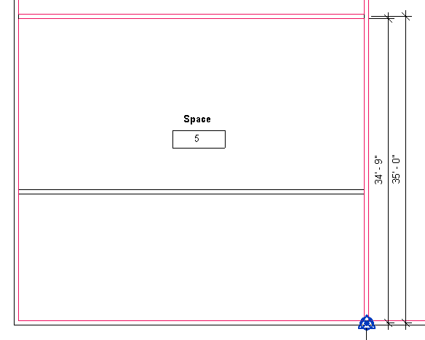

Space 2 Interior Wall

Figure : Space 5 is shown with the interior wall separating Space 2 and 3 also shown so it can be understood furthre how the floor of space 5 should be broken up into two separate floors as per Agreement 0000x

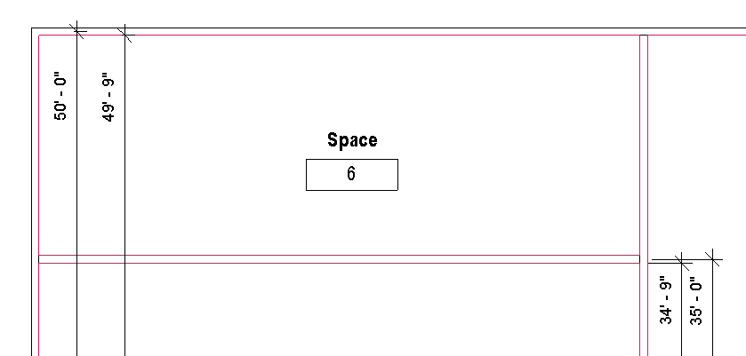

Figure : Space 6 and the locations of the interior and exterior walls are shown.

|  |  |  |  |
| --- | --- | --- | --- |
| Surface Description | Surface Thickness | Construction Type | Comments |
| Exterior Wall | 6” |  |  |
| Interior Wall | 6” |  |  |
| Interior Floor Slab | 6” |  |  |

Table : Details and descriptions of surface elements in Test Case 3.

*Example of the gbXML Code Relevant to this Example*

All of the descriptions relevant to the creation of this gbXML have been defined in the implementation guide